1.WRITE A JAVA PROGRAM TO CALCALUTE THE ARTHIMETIC OPERATIONS

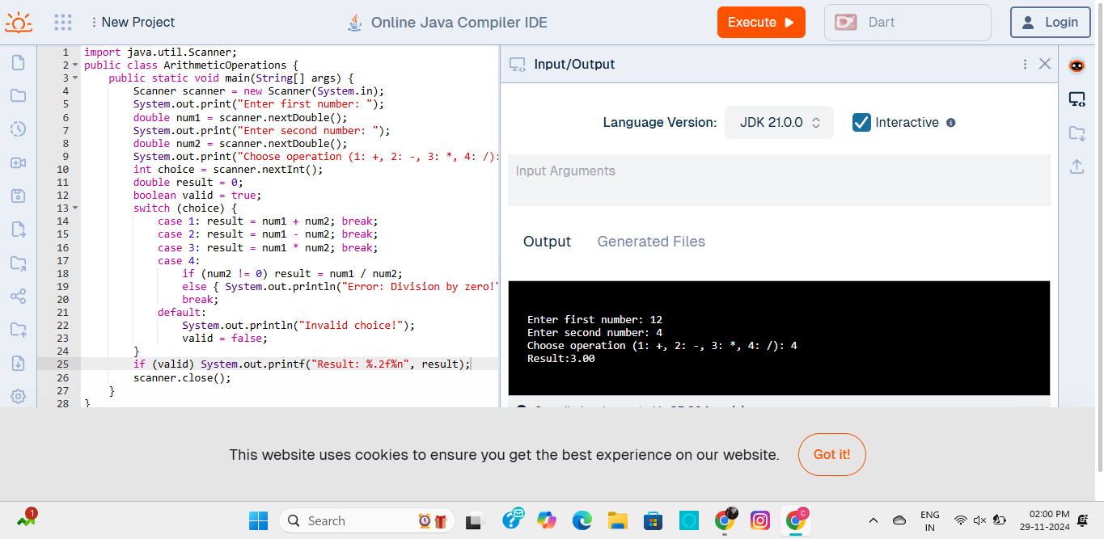

2.WRITE A JAVA PROGRAM TO FIND THE SALARY DETAILS

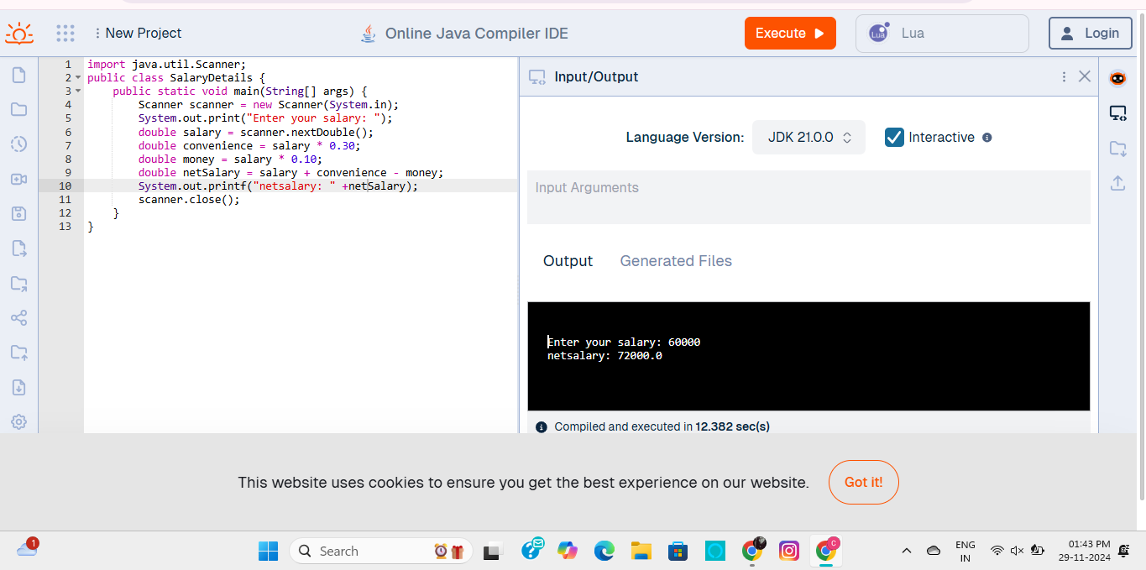

3.WRITE A JAVA PROGRAM TO SHOW THE LOWER AND UPPER CASE, REVERSE AND LENGTH OF STRING

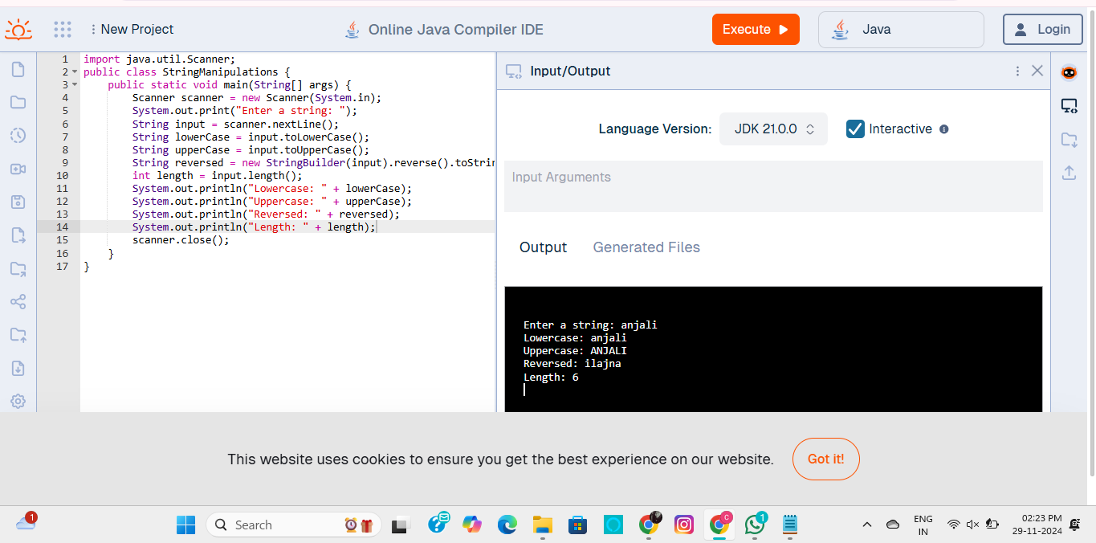

4.WRITE A JAVA PROGRAM TO PERFORM THE GRADE CLASSIFICATION

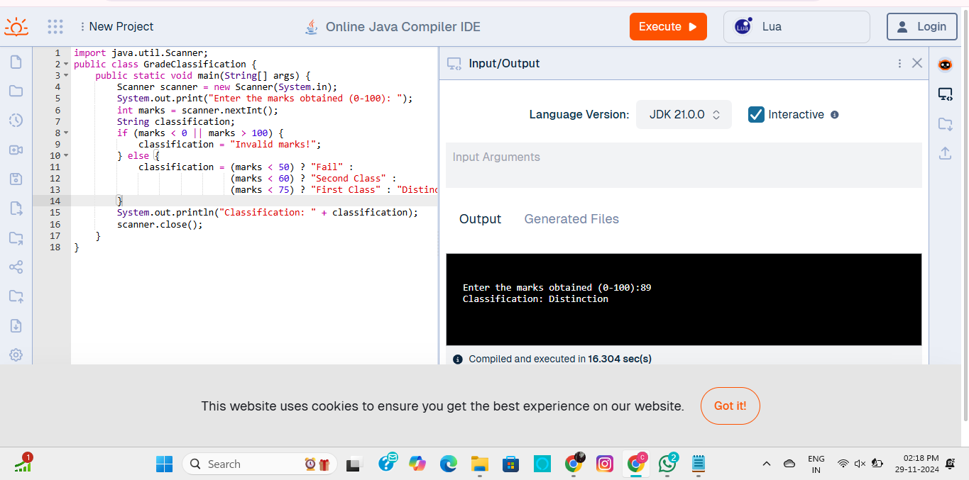

5.WRITE A JAVA PROGRAM TO FIND THE SIMPLE AND COMPOUND INTEREST

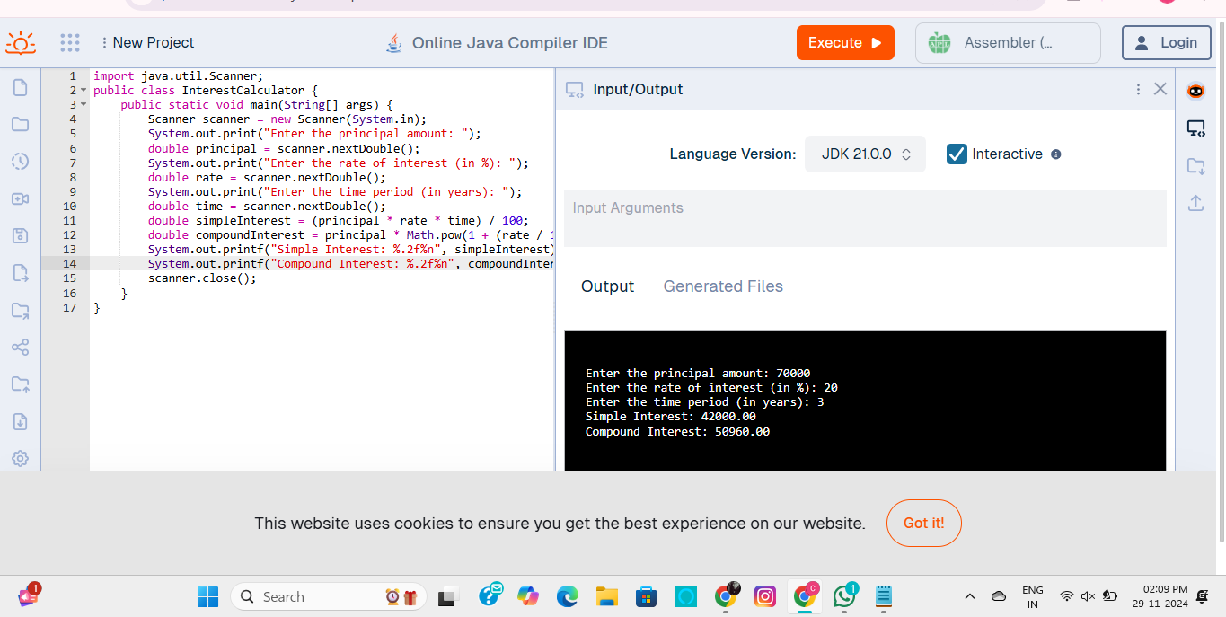

6.WRITE A JAVA PROGRAM TO THE SHOW MONTH USING SWITCH STATEMENT

